IMPORTING DATA GENERATOR LIBRARY:



CONFIGURE DATA GENERATOR CLASS:

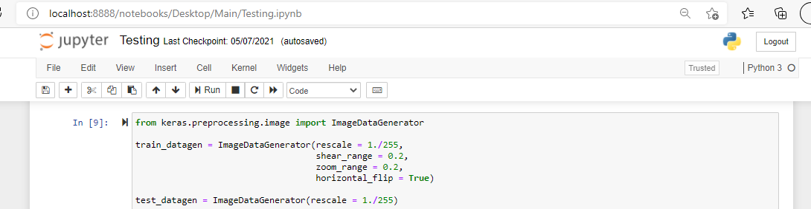

APPLYING IMAGE DATA GENERATOR FUNCTIONALITYTO TRAIN SET AND TEST SET:

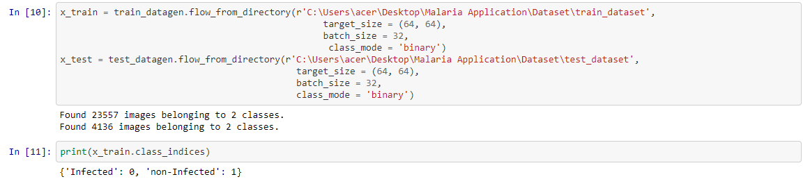

IMPORTING THE MODEL BUILDING LIBRARIES:

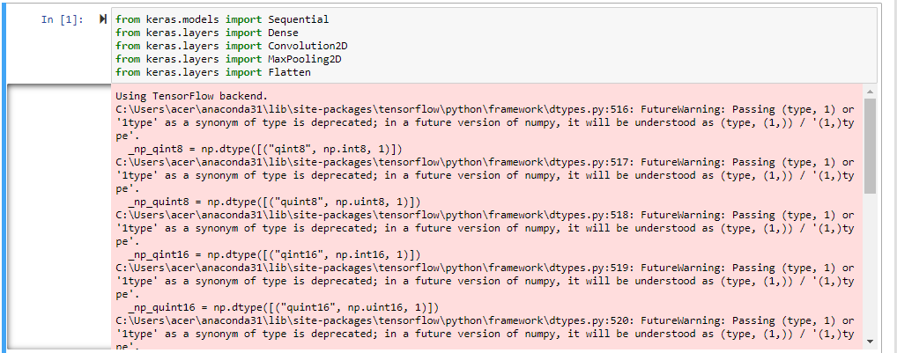

INITIALIZING THE MODEL:



ADDING CNN LAYERS:

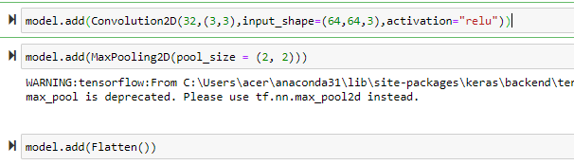

ADDING DENSE LAYERS:

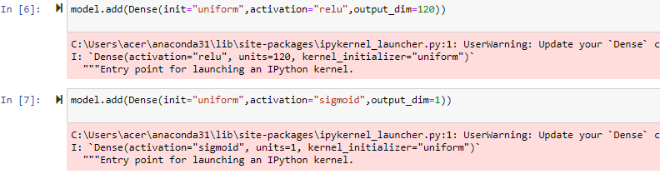

CONFIGURE THE LEARNING PROCESS:



TRAIN AND TEST THE MODEL:

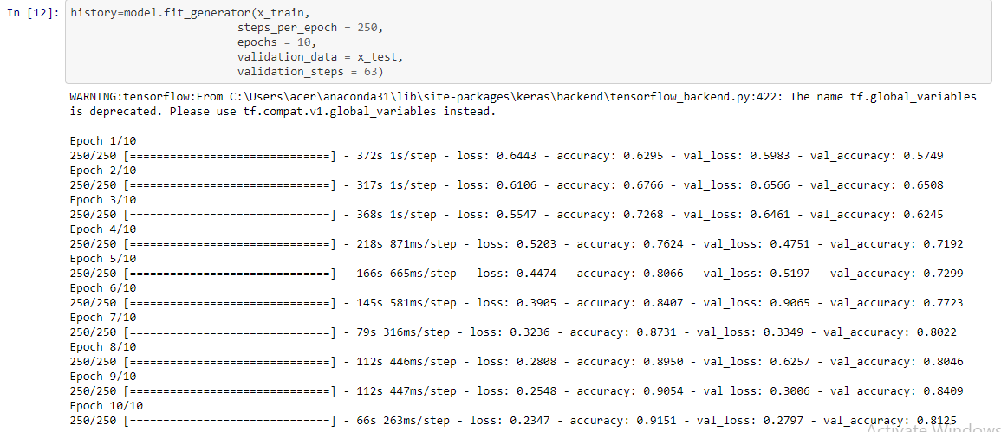

OPTIMIZE AND SAVE THE MODEL:

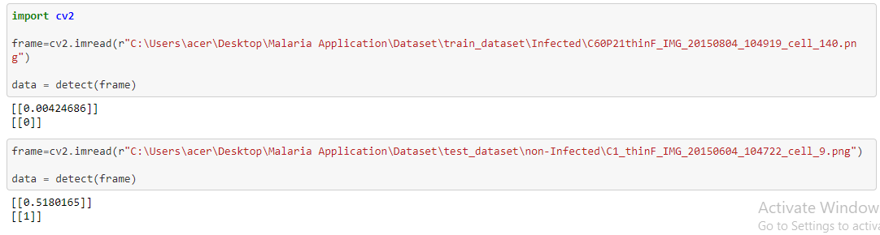

**WORKING WITH FLASK**:

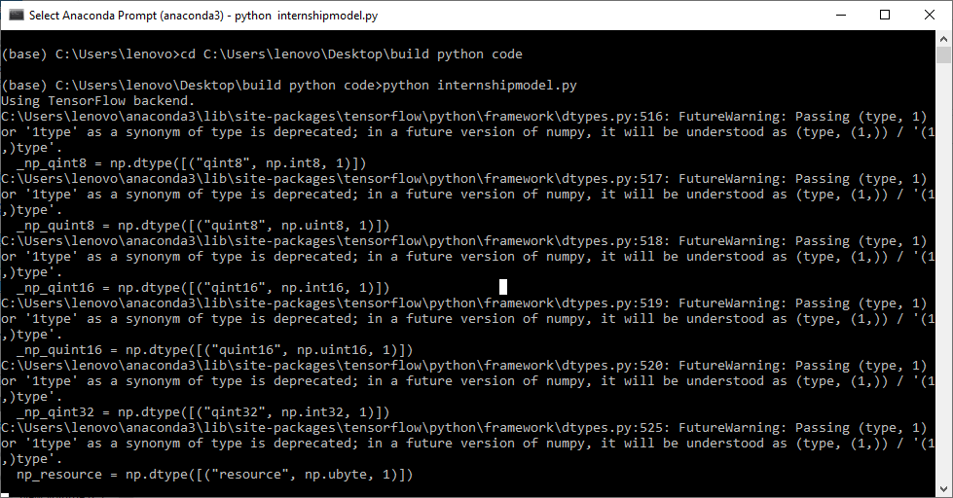

**RESULT:**

